**Directions**

1)I am facing East. Turning to the right I go 20 m, then turning to the left I go 20 m and turning to the right I go 20 m, then again turning to the right I go 40 m and then again I go 40 m to the right. In which direction am I from my original position?

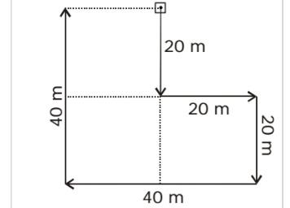

**West**

2) A boy was misdirected from his way while returning to his home from his school. In order to reach his home, he first moved 3 km in south direction and then turned to his left and moved 2 km in straight direction on the road leading to the east. From there, he moved to his left and walked 3 km. After this, he again turned to his left and moved 1 km. Finally he reached his home. The home of the boy was in which direction from his school?

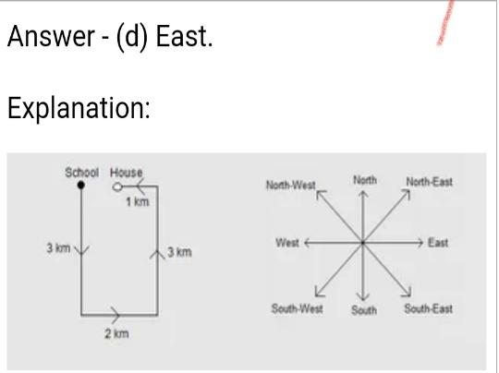

**East**

3)Two boys Anil and Shyam walk in opposite directions for three kilometres. Anil is walking towards East. After 3 km each both turn right and walk 3 km each. Both turn to face each other. In which direction is Shyam looking?

**South East**

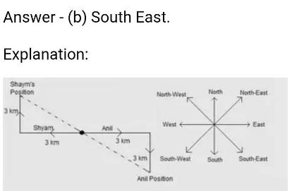

4)At dusk, Rohit started walking facing the sun. After a while, he met his friend and both turned to their left. They halted for a while and started moving by turning again to their right. Finally Rohit waved 'good bye' to his friend and took a left turn at a corner. At which direction is Rohit moving now?

**South**

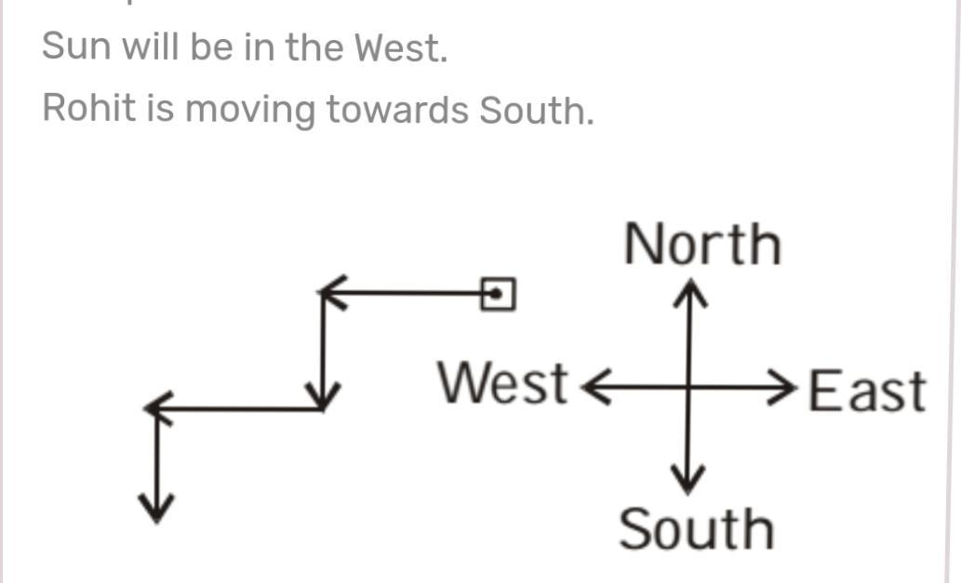

5. Two cars start from the opposite places of a main road, 150 km apart. First car runs for 25 km and takes a right turn and then runs 15 km. It then turns left and then runs for another 25 km and then takes the direction back to reach the main road. In the mean time, due to minor break down the other car has run only 35 km along the main road. What would be the distance between two cars at this point?

**65km**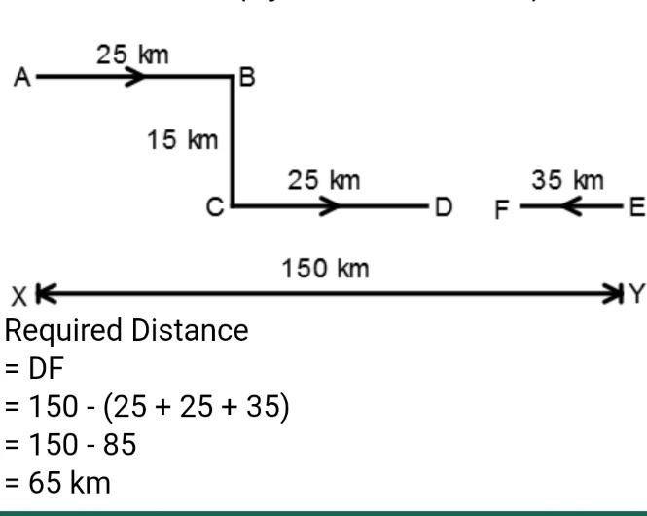

6) A child is looking for his father. He went 90 metres in the East before turning to his right. He went 20 meters before turning to his right again to look for his father at his uncle’s place 30 metres from this point. His father was not there. From here he went 100 metres to the North before meeting his father in a street. What is the smallest distance between the starting point and his father’s position?

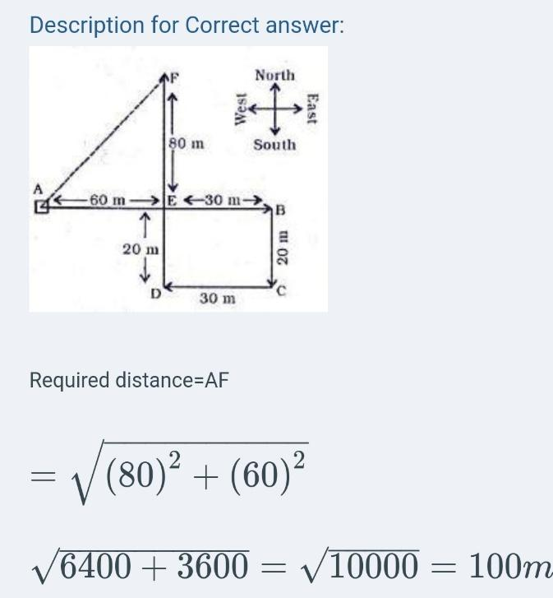

**100 metres**

7.I walk 30 metres in North-West direction from my house and then 30 metres in South-west direction. After this I walk 30 metres in South-East direction. Now, I turn to my house, in what direction am I going?

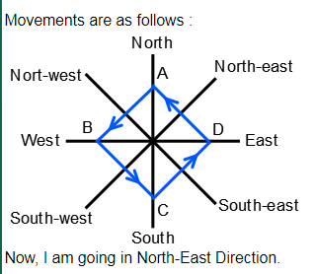

8)A man is facing towards west and turns through 450 Clock-wise, again 1800 Clock-wise and then turns through 2700 anticlock-wise, In which direction is he facing now?

**South-west**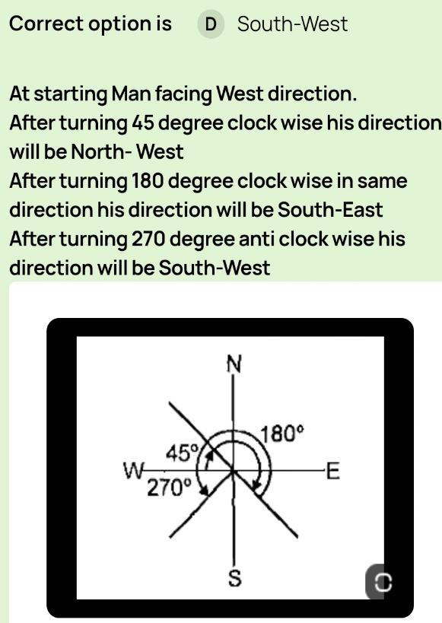

9)Deepa moved a distance of 75m towards the North, She then turned to the left and walking for about 25m, turned left again and walked 80m. Finally, she turned to the right at an angle of 450 in which direction was she moving finally?

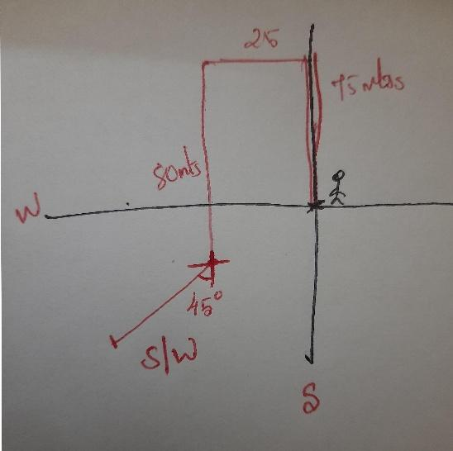

**South-west**

10)Maha is facing North and walks 10km. She turns 2700 anticlock-wise and walks 15km. Now she again turns 450 Clock-wise and walks for 25km. Which direction is he facing now?

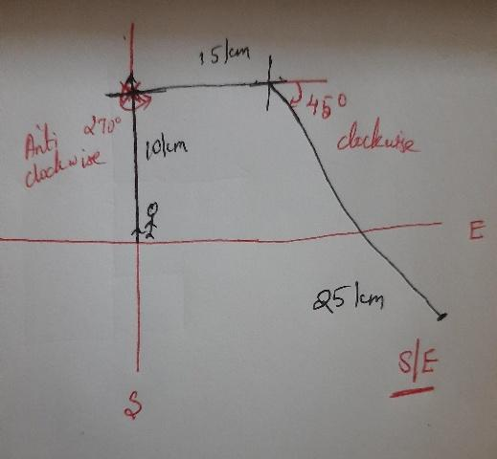

**South-East**

11)Mary is walking towards south-west for 15miles, turns right and walks another 10miles. She then turns 900 clock-wise and walks 10miles , Now she again turns left and walks 30 miles. In which direction is she facing?

**North-west** 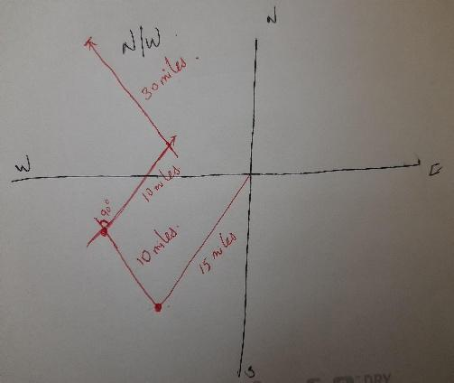

12) Kayal ran a distance of 40m towards south she then turned to the right and ran for about 15metres, turned right again and ran 50metres, turning to right, then ran for 15m, finally she turned to the left at an angle of 450 and ran in which direction was she running finally?

**North-west**

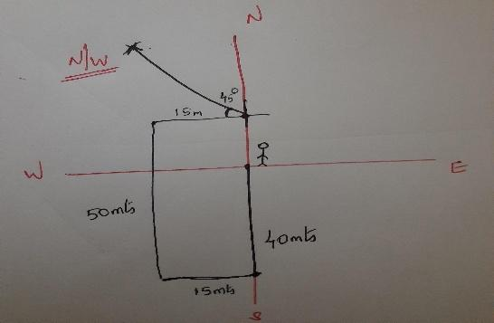

13)Rahul put his time piece on the table in such a way that 6 pm hour hand points to north.In which direction the minute hand will point at 9.15pm ?

**West**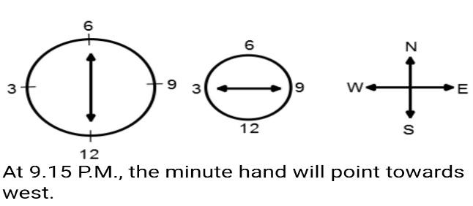

14) One morning Udai and Vishal were talking to each other face to face at a crossing. If Vishal's shadow was exactly to the left of Udai, which direction was Udai facing?

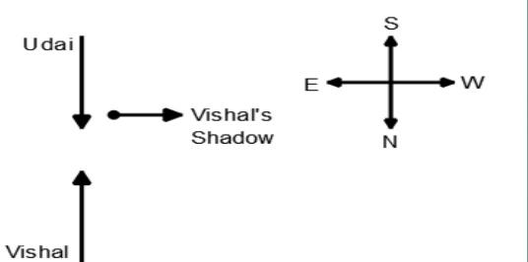

**North**

15)One Evening, before sunset Reka and Hema where talking to each other face to face. If hema’s shadow was exactly to the right of Hema, Which direction was Reka facing ?

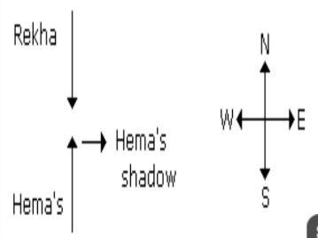

**South**